**Ex 5 PACKAGE MANAGEMENT SYSTEM**

**Date: 08.09.20**

**Aim:**

To study and implement the package management system

**Description:**

**Samba:**

Samba is the standard Windows interoperability suite of programs for Linux and Unix. Since [1992](https://www.samba.org/samba/docs/10years.html), Samba has provided secure, stable and fast file and print services for all clients using the SMB/CIFS protocol, such as all versions of DOS and Windows, OS/2, Linux and many others.

Samba is an important component to seamlessly integrate Linux/Unix Servers and Desktops into Active Directory environments. It can function both as a domain controller or as a regular domain member.

Samba is a software package that gives network administrators flexibility and freedom in terms of setup, configuration, and choice of systems and equipment. Because of all that it offers, Samba has grown in popularity, and continues to do so, every year since its release in 1992.

We’ll create the following Samba shares and users:

**Users:**

* **sadmin** - An administrative user with read and write access to all shares.
* **debby** - A regular user with its own private file share

**Shares:**

* **users** - This share will be accessible with read/write permissions by all users.
* **debby** - This share will be accessible with read/write permissions only by users debby and sadmin.

The file shares will be accessible from all devices on your network. Later in this tutorial, we will also provide detailed instructions on how to connect to the Samba server from Linux, Windows and macOS clients.

**Commands:**

|  |  |  |  |
| --- | --- | --- | --- |
| Sl. No. | Command Name | Syntax | options |
| 1. | rpm | rpm {rpm-file} | **-a, --all**  Query all packages  **-f**  Query for packages owning given file |
| 2. | apt-get | apt-get [options] source pkg1 [pkg2 ...] | **-a**  It prints all the system information in the order  **-s**  It prints the kernel name.  **-n**  It prints the hostname of the network node  **-r**  It prints the kernel release date  **-v**  It prints the version of the current kernel |

**Exercise:**

**1. Install (Samba) free software re-implementation of the SMB/CIFS networking protocol.**

Installing samba using terminal

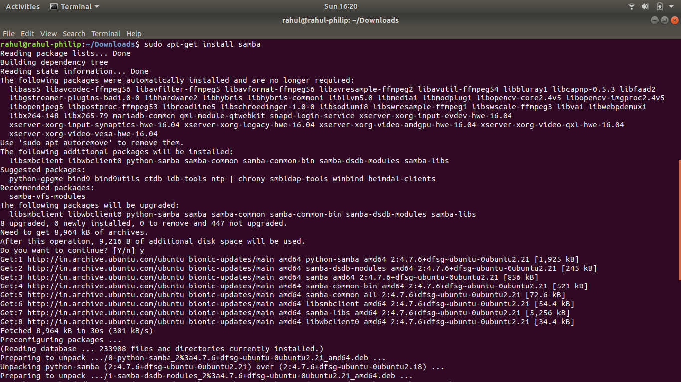

Checking the status of Samba service

Starting the samba services

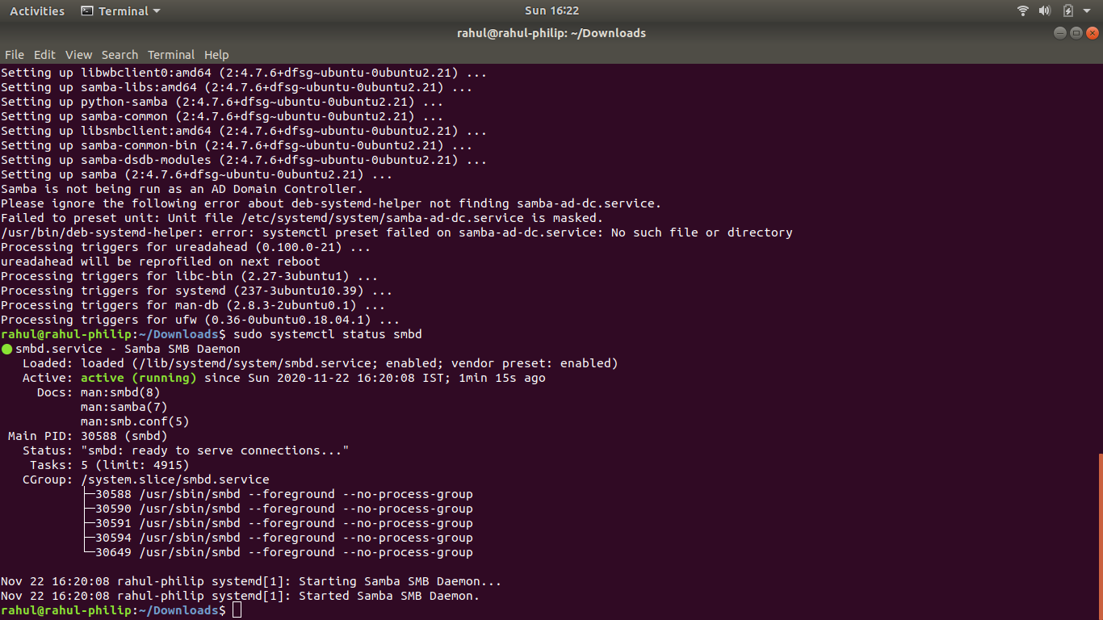

Allow Samba service from firewall

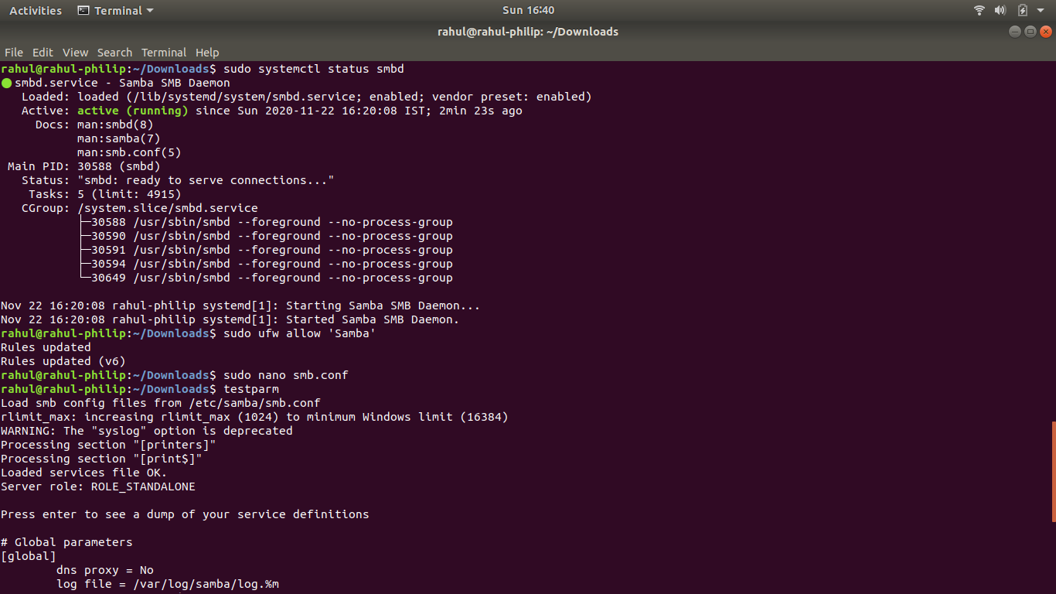

Include the localhost interface in the smb.conf file 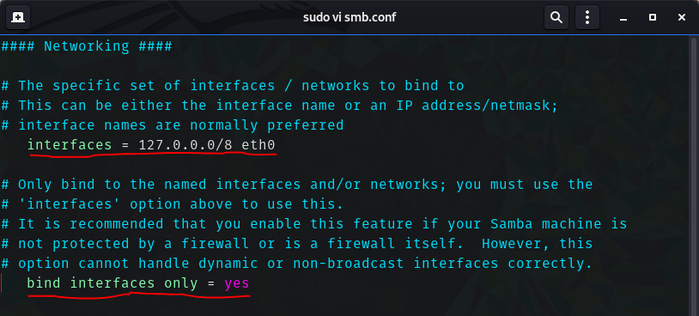

Test the parameters of the smb.conf file

Restart the samba services

Creating a normal user named debby

Setting up the Password for debby

Creating a Admin user

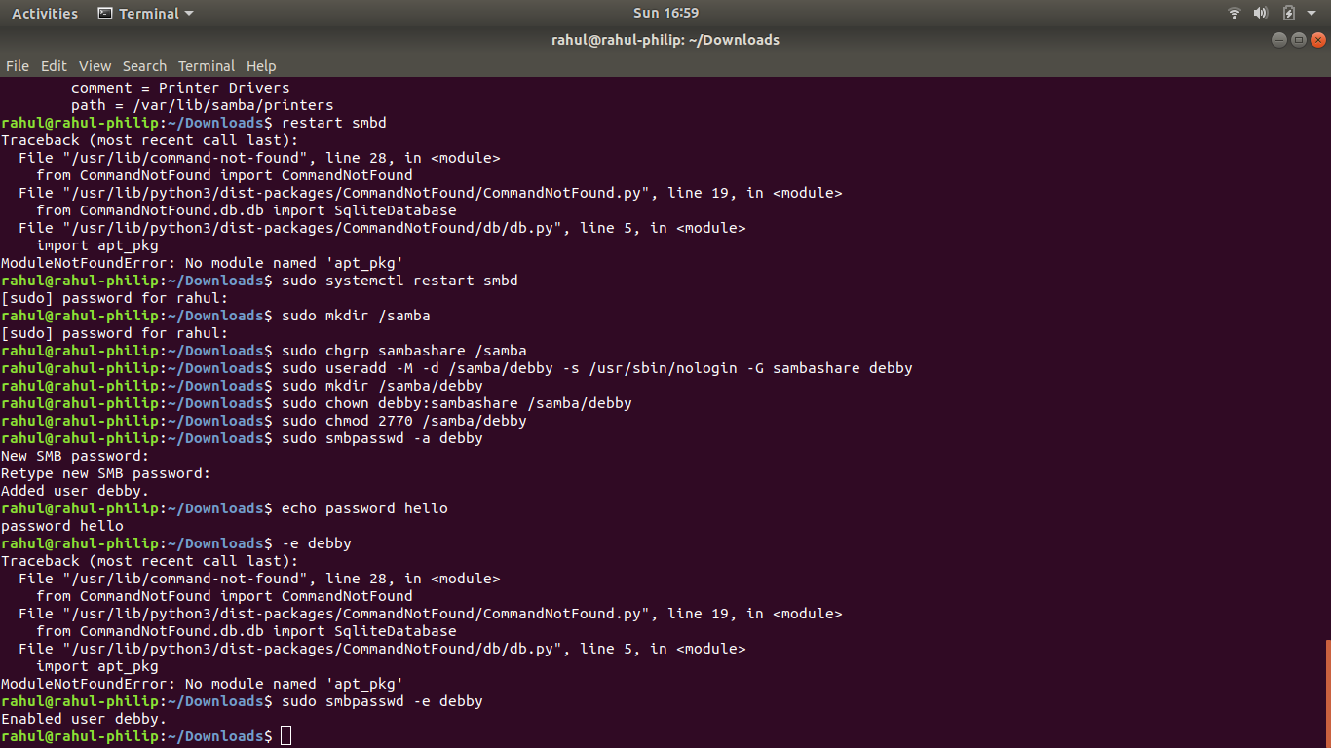

Add this configuration lines in smb.conf file 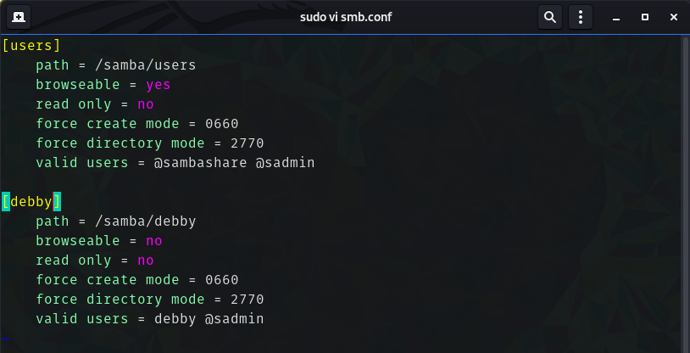

Again Restart the samba services

**2. Install Samba_Client to connect to the samba server**

Installing smbclient from terminal

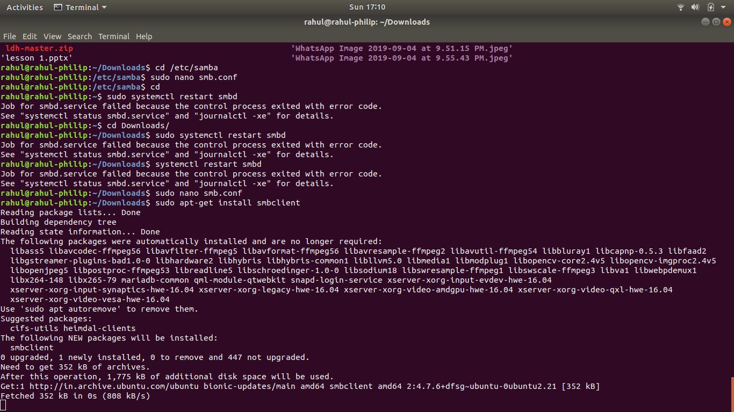

Login into smb server by smbclient and test some commands

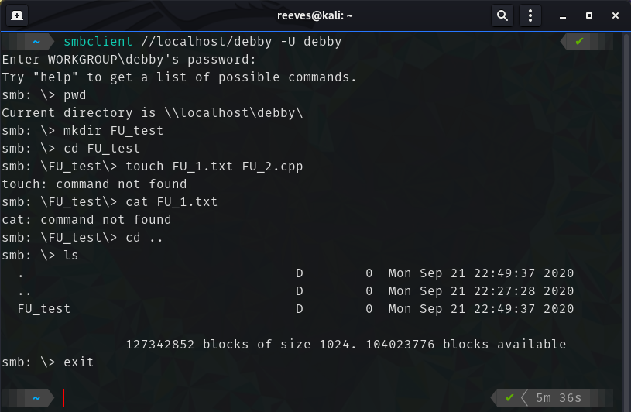

**Results:**

The package management system is studied and executed.

**Video Link:** <https://youtu.be/ZF7-QldT4MM>